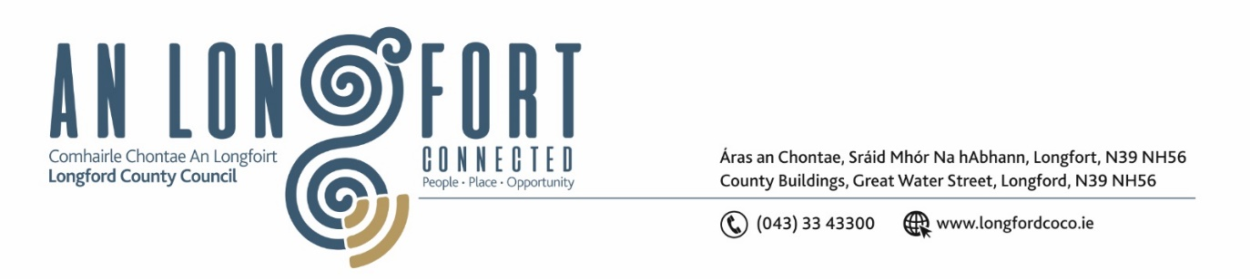

**GRANARD MUNICIPAL DISTRICT**

**Minutes of Meeting of Granard Municipal District held in the Council Chamber, Aras An Chontae and Via Microsoft Teams**

**on Tuesday, 25 October 2022 at 3.30pm**

**CATHAOIRLEACH**: Councillor Colin Dalton

**MEMBERS PRESENT**: Councillors – Garry Murtagh and Turlough McGovern

**IN ATTENDANCE**: Ms. Barbara Heslin, Director of Services

Ms. Linda Higgins, Administrative Officer

Mr. David Coppinger, Senior Executive Engineer

Ms. Fema Flanagan, A/Head of Finance

**APOLOGIES** Councillor PJ Reilly, Paraic Brady

**MEETINGS**

**ADMINISTRATOR**: Ms Ann Marie Mc Keon

**CONSIDERATION OF THE 2023 GENERAL MUNICIPAL ALLOCATION**

Fema Flanagan, A/Head of Finance gave a comprehensive presentation regarding the General Municipal Allocation 2023 under the following headings and replied to queries raised –

* Budgetary Process – under Local Government Reform Act 2014
* Local Property Tax Variation – retain rates for 2023 and 2024
* Source of Funding for Municipal District
* Acute Financial Challenges for 2023
* Delivery of Services with decreasing resources
* Lowest valued LPT base in Country
* Ukrainian Humanitarian Crisis
* Increased Inflationary Pressure
* Financing Payroll requirements and additional pay increases
* Ability to provide ‘match-funding’ for a range of schemes
* Decrease in NPPR income stream
* Loss of rates from Lough Ree Power Station
* Low Rates Base/High Vacancy Rate
* General Municipal Allocation 2023 Recommendation - €90,000 to be distributed as follows – Tidy Town Grants - Town Twinning - Voluntary Bodies Grants – Dring Car Park – Special Project Grants – Christmas Lights – BCP’S
* Granard MD 2022 GMA Committed to date – 77 Groups received funding in 2022 and 25 special projects.
* Governance

**Granard GMA Sub-Service Allocation 2023**

|  |  |  |  |  |
| --- | --- | --- | --- | --- |
| **Service Division** | **Sub-Service** | **Allocation 2022** | **Suggested Allocation 2023** | **Increase/Decrease** |
| **Recreation & Amenity** | **Town Twinning** | **€4,500** | **€6,000** | **€1,500** |
| **Recreation & Amenity** | **Voluntary Bodies Grants** | **€40,654** | **€36,750** | **-€3,904** |
| **Recreation & Amenity** | **Tidy Towns/Development Committees** | **€14,790** | **€15,000** | **€210** |
| **Recreation & Amenity** | **Dring Car Park** | **€0** | **€2,000** | **€2000** |
| **Recreation & Amenity** | **Special Project Grants** | **€25,000** | **€25,000** | **€0** |
| **Recreation & Amenity** | **BCP** | **€1056** | **€1,250** | **€194** |
| **Recreation & Amenity** | **Christmas Lights** | **€4,000** | **€4,000** | **€0** |
| **Grand Total** |  | **€90,000** | **€90,000** |  |

The members thanked Fema for the presentation and acknowledged all the groups that received funding in 2022 and complimented these groups for the works that they did in the community.

On the proposal of Councillor Garry Murtagh, seconded by Councillor Turlough Mc Govern the members unanimously adopted the General Municipal Allocation for 2023.

This concluded the business of the meeting.

**Signed: ____________________**

**Ann Marie McKeon**

**Meetings Administrator.**

**Confirmed and adopted at Granard Municipal District Meeting held on the**

**24 January 2023.**

**Signed: _______________**

**Cathaoirleach.**